REPORT JINST_003T_0125

Report on JINST_003T_0125

Date: January 28, 2025

Author(s): Lifu ZHANG, Jinuo Yu, Jinchen Yang, Ge Zhuang and Jinlin

XIE

Title: The commissioning progress of microwave imaging reflectometer on

EAST tokamak

Received: 2025-01-06 11:23:03.0

Editor report

The paper "The commissioning progress of microwave imaging reflectometer

on EAST tokamak" describes the installed two-dimensional imaging reflectometer

diagnostic and the recent improvements to optimise the signal to

noise ratio (SNR).

The main difficulties of operating such a diagnostic are discussed. A benchtop

experiment is presented, in which the minimum SNR for identifying the

signal from possible background noise is discussed.

Finally, preliminary experimental results of channels distributed on the same

radial position but different poloidal location indicates the diagnostic is able

to detect coherent modes.

The paper is well-structured overall, but certain sections could benefit from

reorganization and a more detailed explanation to enhance clarity and impact,

especially regarding the experimental results and conclusions.

I suggest the authors consider the following points to strengthen the manuscript

and bring it to the standard required for publication. For the following reasons,

I would recommend a major revision of the work.

Chapter 4.1 is probably the less clear and I have the following points:

1 - The manuscript includes the use and presentation of DIII-D data. However,

there is no citation, acknowledgment, or mention of DIII-D contributors.

I would kindly ask the authors to clarify this point and ensure proper attribution

to align with standard publication practices

Thank you for this comment. As the collaboration agreement has expired, I have removed the DIII-D data from this manuscript and instead included references to DIII-D MIR.

2 - Figure 7 requires significant clarification. The figure lacks x- and y- axis,

it is not mentioned whether the data are comparable, under which experimental

condition the MIR data have been collected and so on. Furthermore,

please specify the radial and poloidal positions instead of only providing the

channel numbers to improve interpretability

Thank you for the question and recommendation. The fig.7 has been replaced with 2D MIR observation window plot, and raw data plot.

3 - It is unclear what the authors mean with the sentence "it is found that

the evolution of raw data provide direct clues to calibrate the optics and

optimize the MIR performance" (line 77, page 7). Could the authors please

clarify this point for better understanding?

Yes. I agree with you. This statement confuses people. We replace that as a new paragraph as “The quality of MIR data is closely tied to optical alignment. When misalignment occurs , the reflected beam fails to be accurately received by the designated receiver antenna. Instead, it spreads into a larger beam spot, covering multiple receiver antennas, which induces crosstalk between different poloidal channels. In a single-transmitter system, this crosstalk directly introduces interference, compromising the integrity of the raw data. During actual measurements, this interference appears as "dark zones," where signal intensity is reduced, and the signal-to-noise ratio deteriorates.”

In reference #xxx, Chris has already discussed the relationship between optical alignment and the quality of MIR raw data. Properly aligned optics produce clear phase fluctuations on the IQ plot with a narrow line width, as highlighted in red. Conversely, misalignment results in a mix of phase and amplitude modulation, as indicated in blue.

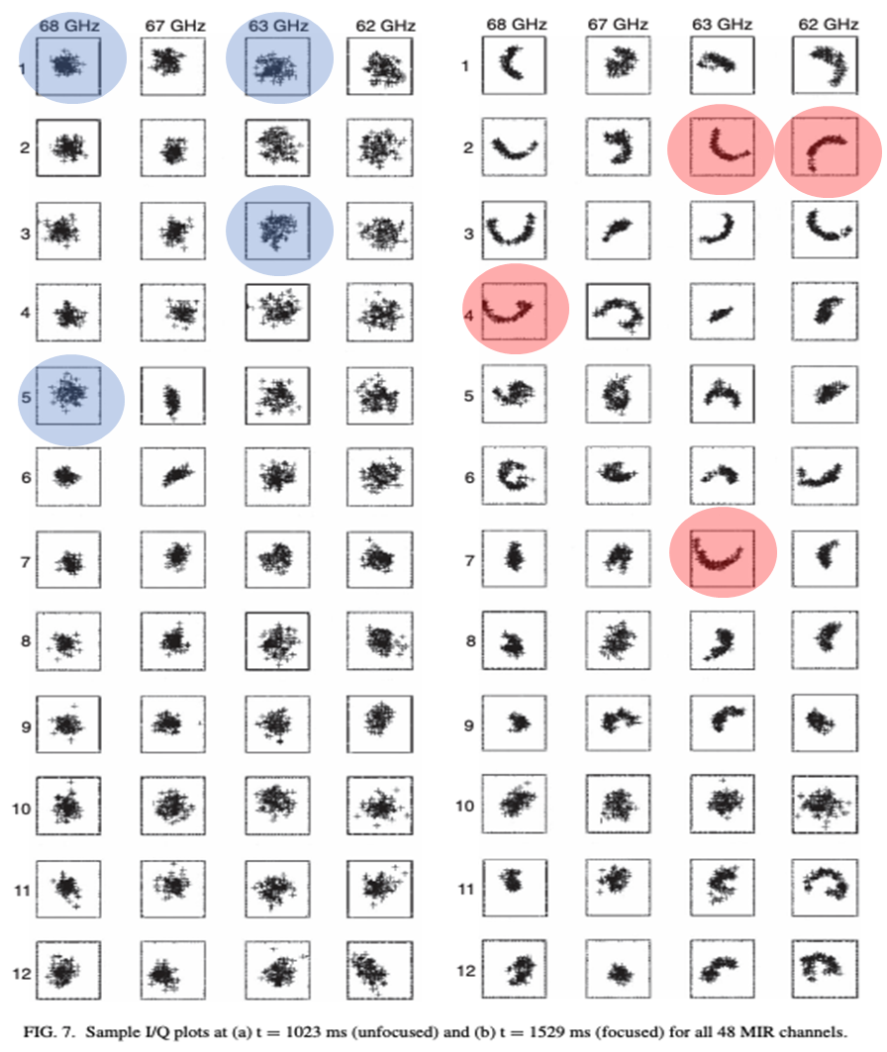

Regarding the rest of the paper:

4 - It is stated in the introduction that the performances are far from satisfactory

if compared to ECEI. It would be beneficial if the authors added a

sentence clarifying the advantages of an MIR system over an ECEI.

Thank you for this recommendation. We add more description about the MIR benefits.

Unlike the passive 2D imaging radiometer, Electron Cyclotron Emission Imaging (ECEI), MIR measurements encounter greater challenges in achieving clear 2D density fluctuation imaging. These challenges stem from complex coherent wave receiving, interference between different poloidal and radial channels, and potential misalignment between the transmitter wavefront and the plasma cutoff layer. Despite these difficulties, the MIR system offers a unique capability for co-located and simultaneous measurements of both density and temperature fluctuations alongside ECEI. This capability is essential and highly valuable for studying MHD instabilities and turbulence transport in long-pulse plasma discharges. A clear understanding of these physical phenomena is crucial for the design and safe operation of fusion plasma devices.

5 - Page 1, last line: The sentence "the published images of 2-D fluctuations

are very limited" is unclear. Could the authors clarify which specific images

they are referring to in this context?

Thank you for this question. Sorry for the confusion. The active MIR system development and implementing facing more challenges than the passive ECE Imaging system. As we address on the responding in comment # 4, we already replace that with

Unlike the passive 2D imaging radiometer, Electron Cyclotron Emission Imaging (ECEI), MIR measurements encounter greater challenges in achieving clear 2D density fluctuation imaging. These challenges stem from complex coherent wave receiving, interference between different poloidal and radial channels, and potential misalignment between the transmitter wavefront and the plasma cutoff layer. Despite these difficulties, the MIR system offers a unique capability for co-located and simultaneous measurements of both density and temperature fluctuations alongside ECEI. This capability is essential and highly valuable for studying MHD instabilities and turbulence transport in long-pulse plasma discharges.

6 - Figure 1: Could the authors clarify what MIR RX and MIR TX stand

for? Please provide a brief description either in the caption or in the main

text to help the reader understand.

Sorry for those missing definitions. The Tx stands for ‘transmitter’. The Rx stands for ‘receiver’. Those have been defined in the updated manuscript and figure.

7 - Figure 2: the image is not very well readable. It might be beneficial to

use a higher quality version.

It has been replaced with a high resolution figure.

8 - Section 3.2, page 5, line 142 - 148. Is it possible to quantify the contribution

of the crosstalk to the overall noise?

Thank you for your question. The crosstalk occurs due to the coupling of the microwave transmission line with other reference signals on the same printed circuit board (PCB), introducing phase modulation to neighboring channels. The maximum crosstalk level can exceed 20% in amplitude, leading to uncertainty in the radial measurement location. This issue has now been resolved through optimized component selection, reducing the crosstalk to below **1%** in the current system setup.

9 - Section 3.3, page 6, line 163 - 167: here it is not fully clear to me what

these ranges refer to. Could the authors add a couple of sentences or briefly

restructure the chapter to make clearer the relation between the radial observation

range (50-400 mm), the wavefront curvature and then the radial resolution which can be adjusted from 18.8 - 30.8 mm?

Yes. I agree with you. This paragraph has been revised as

The MIR measurement radial coverage is **xx mm** at a major radius of **R = xxxx mm** and **xx mm** at **R = xxx mm, based on the standard EAST plasma equilibriums (shot number)**. The transmitter wavefront curvature radius is dynamically adjustable from **640 mm to 1560 mm** to accommodate different EAST plasma scenarios. On the receiver side, five high-density polyethylene (HDPE) lenses and two flat mirrors are used to receiver the reflected waves from the plasma, and direct them to the 12-channel antenna array [14]. The image plane curvature radius ranges from **570 mm to 850 mm**, depending on the plasma scenario. The spatial spacing between neighboring radial channels is adjustable from **18.8 mm to 30.8 mm**, allowing for the study of different-scale radial transport physics.

10 - Please explain what the acrononym HHT stand for.

Thank you for your comment. HHT stands for Hilbert-Huang Transform, which is used for real-time phase detection in MIR raw data. It has been updated in the manuscript as follows:

The laboratory testing results shows the input power ratio should stand higher than 1.97 for the the Hiber-Huang Transform-based (HHT) for real-time phase measurement. The signal-to-noise ratio at reflection beam input stage should be above 1.97 for reliable density fluctuation measurement on EAST MIR system.

11 - In section 4 it is shown under which SNR the system is able to detect fluctuations, however in section 5 the noise level is not discussed. How do the signals after the optimization look like with respect to Figure 7b? I would suggest to highlight in section 5 how the improvement / analysis performed in section 4 contributed to the results.

Thank you for your question. Figure 7 illustrates the raw signal before optimization, where low power from plasma reflection and high interference from unexpected optical path reflections—not from the plasma—result in poor signal quality. This serves as an example of bad coupling before optimization. In Section 5, we present the improvements in MIR system performance following laboratory studies, where optimized optical coupling effectively suppresses unexpected reflections and enhances the raw data signal-to-noise ratio, reaching up to **xx**. The optimized system configuration brings clear plasma measurement data, as shown in Fig. 11. It brings clear physics results about the coherent mode on EAST.